# **VBS to HFSS without GUI**

**Step 1:** Open the .VBS file with word pad and go to the bottom and change the file location where you want it to be saved and rename it.

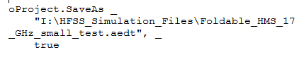

**\*\*Make sure the HFSS file name is different for each VBS file, otherwise it will rewrite the old file and will lose it. DO NOT double click the VBS file, it will directly run and start building on HFSS**

**Step 2**: Open command window and go to the location where the VBS file is located.

C:\Users\abisw002>I

I:\>**cd** \HMS\Foldable HMS\VBS Files

I:\HMS\Foldable HMS\VBS Files>

**Step 3:**

Now, Copy and paste the highlighted portion below right after the step 2 in the command window and rename the red highlighted portion as the same name of your VBS file name. Hit enter.

I:\HMS>"C:\Program Files\AnsysEM\**AnsysEM21.1**\Win64\ansysedt.exe" -features=beta -ng -runscriptandexit **VBScriptname**.vbs

*\*\* Check the ANSYS version in your computer following C:\Program Files\AnsysEM\ this path and update it accordingly.*

This should create a text document in the VBS file location denoting the status of the file. When the process ends, it should create an HFSS file at the location mentioned in Step 1.

